These Are The 9 Zero Hedge Charts Showing "Obama's Recovery" That Angered The Washington Post

by Tyler Durden - Jun 3, 2016 3:16 PM
FacebookTwitterGoogle+LinkedInReddit
As regular readers know, one of our favorite chartpacks to show "Obama's recovery" is the one below, presented most recently just two days ago during Obama's now almost weekly televised sermon of how the economy is great and anyone who disagrees is "peddling fiction", which using simple Bloomerg data, summarize recent changes in key economic indicators including soaring federal debt and government dependency via food stamp use, surging healthcare costs and social inequality, plunging homeownership, income, and labor force participation, and - of course - driving it all, none of the president's or Congress' actions, but the Fed's balance sheet, something even major banks admit is better known as "printing money" - money that ends up blowing one after another asset bubble unable to finds its way into the broader economy - a stigma that is now gone in a world in which helicopter money is seriously considered by lunatics in power.
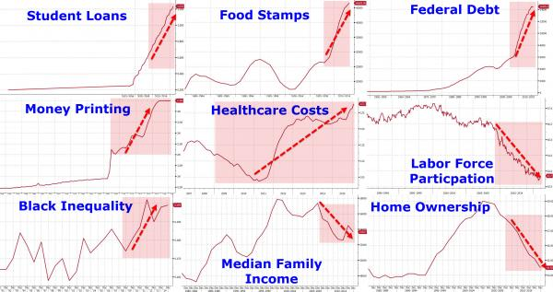

To be sure, the charts do not in any way imply that Obama started any of these disastrous trends (with a few exceptions); they do however make it very clear that more than 7 years under president Obama, these same trends have not changed.
This means that while Obama may have inherited a bad economy, contrary to the endless propaganda, the economy has only gotten worse. One needs only to go on a very short drive through any of the neighborhoods of Obama's native Chicago to get a clear realization of this sad fact (while wearing a bulletproof vest).
Then yesterday, we were pleasantly surprised to see that none other than Donald Trump used this very chart set to demonstrate a point, namely that "Obama's legacy is an absolute disaster", something we doubt many would disagree with.
View image on Twitter
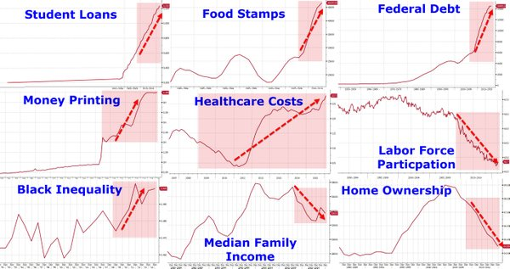

Follow
Donald J. Trump
✔@realDonaldTrump
"@TaylorEdwards99: THIS IS @POTUS'S LEGACY! AN ABSOLUTE DISASTER!!! WE NEED @realDonaldTrumpNOW!! #MAGA #TRUMP2016
6:20 PM - 2 Jun 2016

5,8225,822 Retweets

11,49611,496 likes
However, one entity that would naturally be offended by nice simple charts which factually expose the failure behind both the propaganda and Obama's attempt to jump start the economy, was Jeff Bezos' Washington Post, an outlet which has had a long-running vendetta with Donald Trump, and, apparently, the facts.
We were beyond amused when the WaPo's decided to "fact check" these charts which are, well, based on facts sourced by the very government the WaPo so strenuously defends.
The purchased by Jeff Bezos website writes that "we have generally learned that there's not much utility in fact-checking every tweet that springs to life from the imagination of Donald Trump or which receives his blessing via retweet. Tweets containing factual errors are not as plentiful as those containing exclamation points or disparagement, but they aren't exactly rare. But on Thursday evening, Trump retweeted this one, and we -- well, I -- couldn't let it stand."
As author Philip Bump, who apparently has never encountered a Bloomberg terminal before, says, "there are nine little graphs embedded in there, with hard-to-read axes and unclear provenance for the numbers, all of which are meant to bolster one argument: Barack Obama's presidency has been bad."
Well, Philip, you can interpret the "bolstering" in any way you want, what you can't however interpret are the facts - which is what those charts show. Of course, everyone can make up their own conclusion about what the ongoing economic deterioration means: one can even say that almost 8 years later, it is still "Bush's fault."
Alas, we were naive to assume that the WaPo can't "fact-check" charts based on facts. Because that is precisely what they did. And in doing so it provided much amusement. Case in point, the author's "analysis" of the Fed's money printing by way of proxy of its balance sheet, something this "fact-checker" apparently couldn't figure out. Instead, he said the following.
Money printing

This one is probably my favorite. I'm not going to get into the politics of the printing of money and why certain quarters object to the practice. Instead, I'm going to try to figure out what the 4 million figures on the vertical axis indicate -- and what the numbers along the bottom are.

The Federal Reserve (naturally) has lots of data on money in circulation, including this chart of print orders by year since 1995. It doesn't match the graph Trump tweeted.

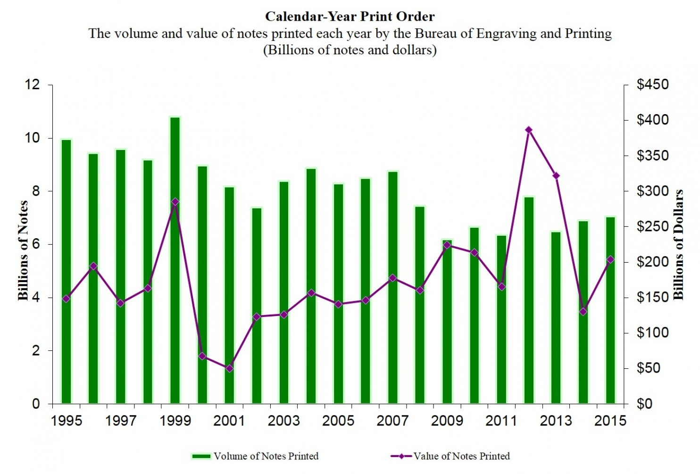

Data.gov (a great resource, by the way) has the number of notes produced each year from 1980 to 2012 in various denominations. Combined, those numbers don't result in 4-million-plus of anything -- they add up to far more. The Department of the Treasury indicates that it produced 24.8 million notes a day in 2014.

So what is this graph? No idea. If you have an idea, let me know.
And there you have it: a WaPo fact-checker who is unable to immediately grasp that the "4 million figures on the vertical axis" have nothing to do with volume or value of notes printed, and everything to do with the size Fed's balance sheet.
Oh, and Philip, it's not million... it's trillion with a T, feel free to "fact check" for yourself here.
Needless to say, realizing we are working with a "fact-checker" who is incapable of grasping out of context the simplest thing about the entire so-called recovery, namely that the S&P 500, pardon the "economy" has been driven not by the president or by Congress, but by the Fed and its balance sheet, something this "expert" couldn't figure out from the context, we stopped reading there.
We are confident there are more pearls in the full article below; we hope readers are entertained.
* * *
[Best read Phillip Bump’s words from their source, so you’re sure he’s accurately quoted: https://www.washingtonpost.com/news/the-fix/wp/2016/06/03/fact-checking-donald-trumps-nine-graph-tweet-proving-that-obama-has-failed/ ]

Here is WaPo with "Donald Trump tweeted out 9 graphs proving that Obama failed. We fact-checked them."If we had a standalone "tragicomedy" section, it would be published in it.
* * *
We have generally learned that there's not much utility in fact-checking every tweet that springs to life from the imagination of Donald Trump or which receives his blessing via retweet. Tweets containing factual errors are not as plentiful as those containing exclamation points or disparagement, but they aren't exactly rare.

But on Thursday evening, Trump retweeted this one, and we -- well, I -- couldn't let it stand.

"@TaylorEdwards99: THIS IS @POTUS'S LEGACY! AN ABSOLUTE DISASTER!!! WE NEED@realDonaldTrump NOW!! #MAGA #TRUMP2016 pic.twitter.com/lBgZJg0zd1
View image on Twitter

Follow
Donald J. Trump
✔@realDonaldTrump
"@TaylorEdwards99: THIS IS @POTUS'S LEGACY! AN ABSOLUTE DISASTER!!! WE NEED @realDonaldTrumpNOW!! #MAGA #TRUMP2016
6:20 PM - 2 Jun 2016

5,8225,822 Retweets

11,49611,496 likes
There are nine little graphs embedded in there, with hard-to-read axes and unclear provenance for the numbers, all of which are meant to bolster one argument: Barack Obama's presidency has been bad.
Look, for example, at the graph at upper left, "Student Loans." It's almost impossible to make out the labels on the horizontal axis, but it's clear that there simply aren't any until the graph starts to rise.

Which is ... a bit deceptive. So what I figured I'd do is try my best to recreate these charts with verifiable numbers, to see how this argument stacks up.

Student Loans

The vertical axis on this one tells us what we're looking at. It passed "1.000" at some point recently; the third labeled section of the graph appears to demarcate 2010-2014. (The others, I think: 2000-2004 and 2005-2009.) If it passed 1 recently, then we're talking about student loan debt, in dollars.

The Federal Reserve has data going back to the first quarter of 2006, allowing us to create a slightly more legible version of the graph

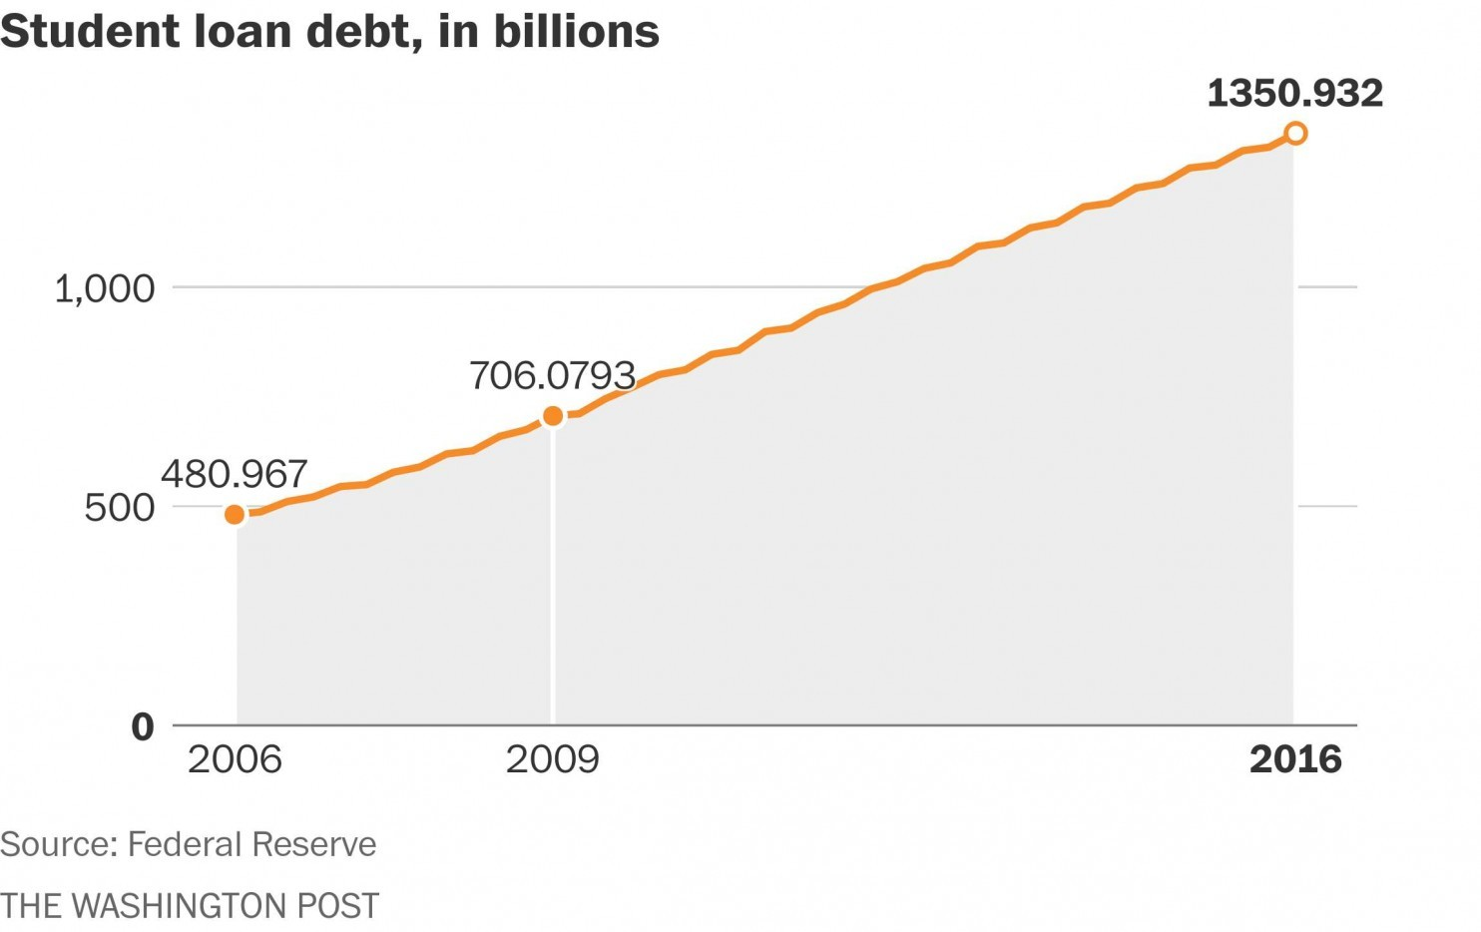
(We've highlighted 2009 on our charts to emphasize the point at which Obama took over.)

On an old page from 2012, we find the trend extending back a bit more. The trend, then, isn't a big spike. It's a steady increase since about 2006 -- before Obama was president.

Food Stamps

Here, the horizontal axis extends a bit further back, still in those odd five-year chunks. What's being tallied here is not "food stamps," which makes no sense, but average participation over the course of each year, in millions. In other words, the average of how many people used the Supplemental Nutrition Assistance Program (SNAP) each month of the year.

That data is available from the USDA.

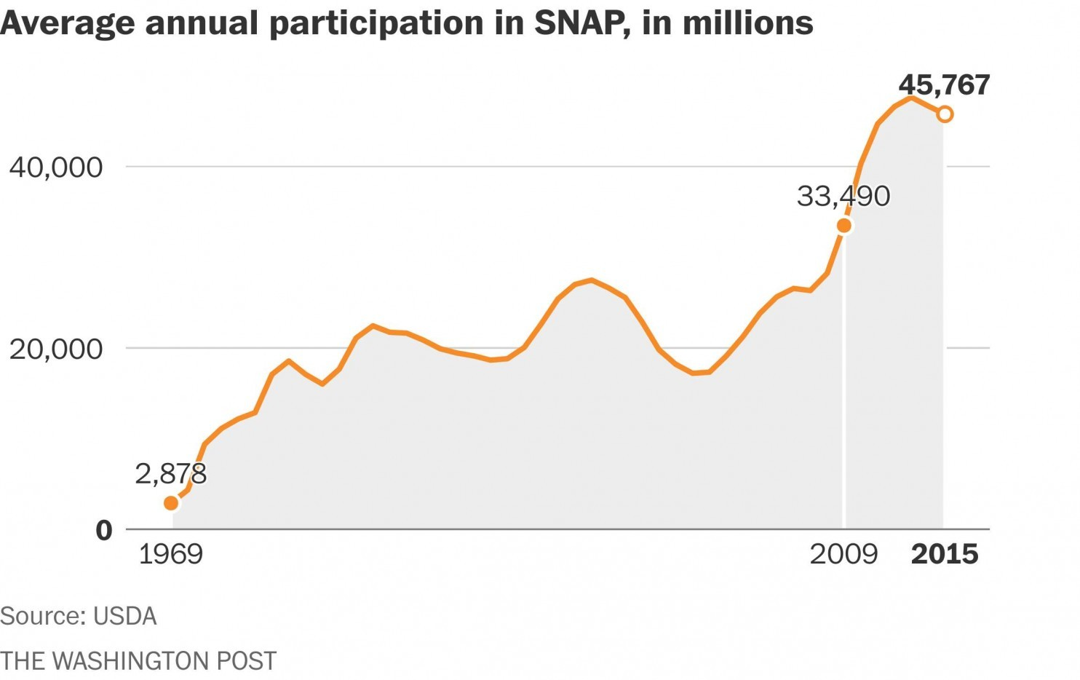

There was an uptick -- one that began in 2008, which we'll get to. But notice that the person who made this chart cut it off before the number started to (slowly) drop back down.

There's a theme you'll see present itself here: That Obama took office right after the recession began. As a result, he appears to perform poorly on some metrics, like this one. But that's a natural result of the financial crisis that predated him: more people relied on supplemental assistance.

Federal Debt
...And the government took on more debt.
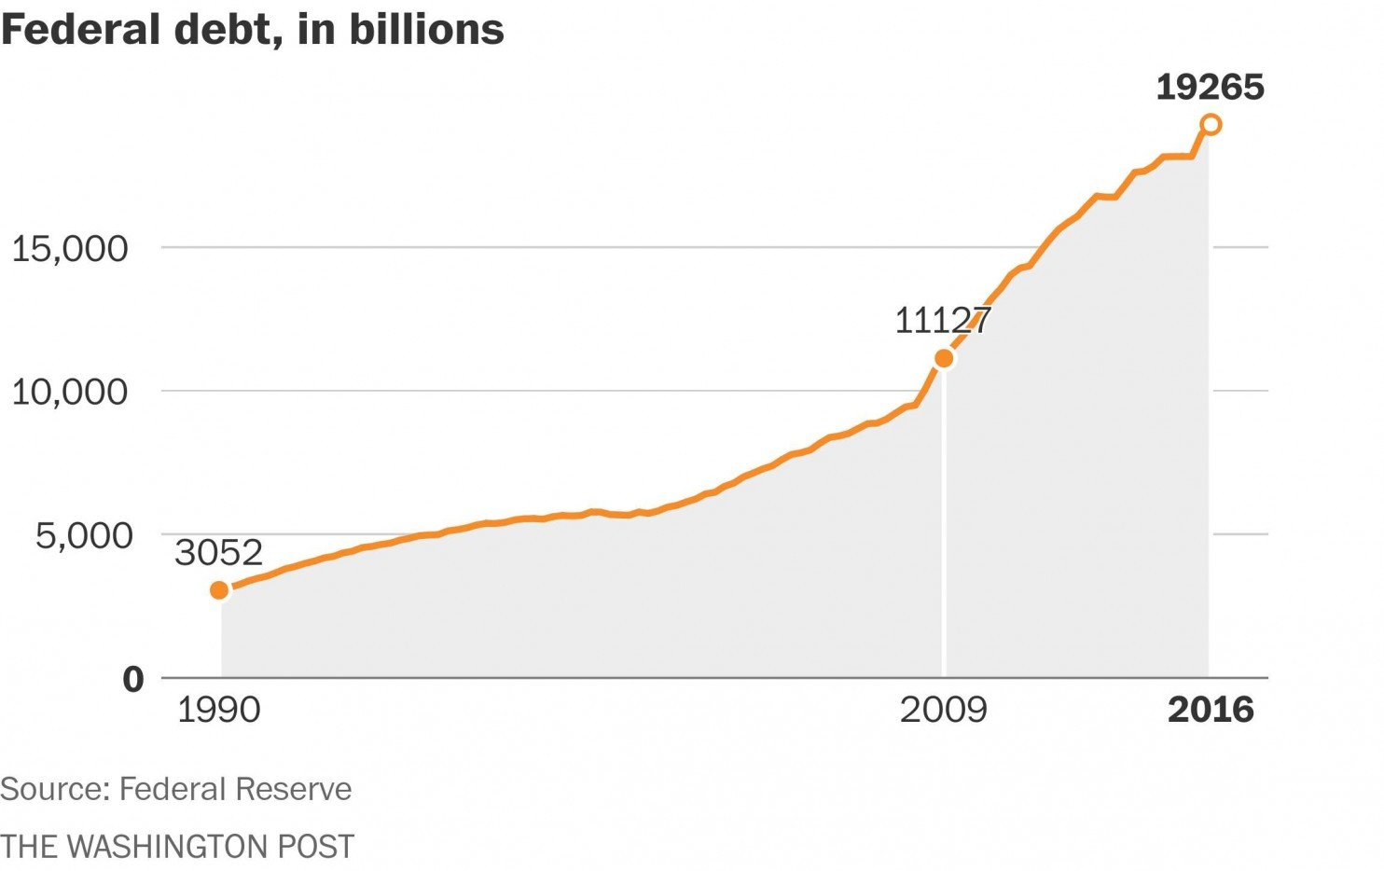

Notice that on the debt chart in the original, the horizontal axis has changed. No longer does it start in the 1980s -- instead, it goes back to 1950. Yes, debt increased under Obama by a large amount. But, again, that increase began under his predecessor, George W. Bush, as an effort to address the financial crisis.

What's more, comparing 1950 to 2000 makes little sense, since the value of the dollar wasn't equivalent at that point. But compared to the other problems here, that's relatively minor.

Money printing

This one is probably my favorite. I'm not going to get into the politics of the printing of money and why certain quarters object to the practice. Instead, I'm going to try to figure out what the 4 million figures on the vertical axis indicate -- and what the numbers along the bottom are.

The Federal Reserve (naturally) has lots of data on money in circulation, including this chart of print orders by year since 1995. It doesn't match the graph Trump tweeted.

Data.gov (a great resource, by the way) has the number of notes produced each year from 1980 to 2012 in various denominations. Combined, those numbers don't result in 4-million-plus of anything -- they add up to far more. The Department of the Treasury indicates that it produced 24.8 million notes a day in 2014.

So what is this graph? No idea. If you have an idea, let me know.

Health-care costs

You've probably noticed by now that the pink boxes in the Trump tweet generally approximate the period during which Obama was president. It varies a bit, but that's generally the case.

So you'll notice on this one that the creator of the charts cheats, making most of the graph a period during which Obama was president. It starts in 2007 and goes through 2015.

"Healthcare costs" is vague. The Kaiser Family Foundation has a tool that allows you to see expenditures under a number of scenarios since 1960 -- but none of its charts appear to sync with the one Trump tweeted.

The Federal Reserve, as always, has some data. In this case, it's health expenditures per capita. They've gone up steadily, at least through 2012. The Kaiser data shows about the same thing.

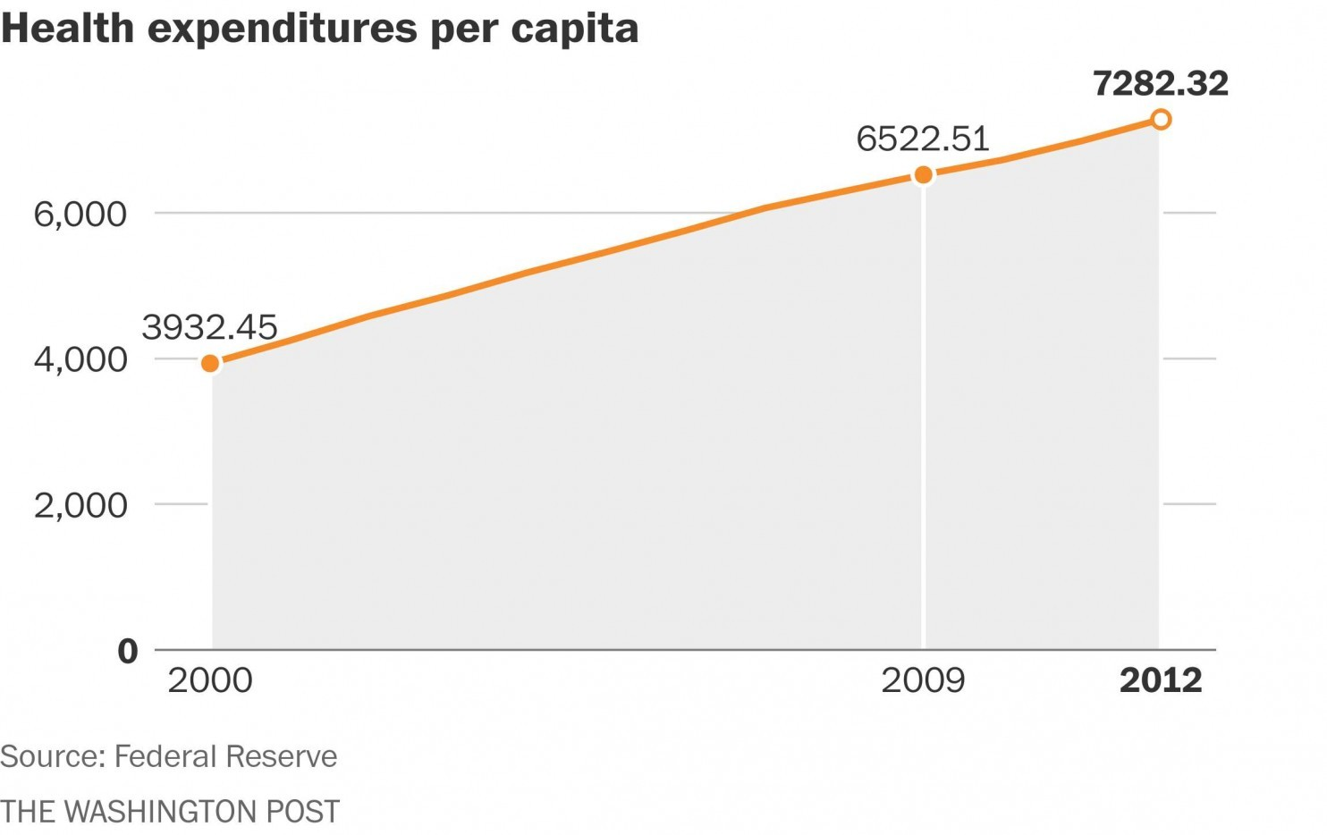

What's Trump's chart? I'm not sure. Notice that the vertical axis on it begins at 105, not zero, making the amount of change seem exaggerated. It's possible that the figures are percentages, indicating how muchcosts were relative to the prior year. But while 2011 costs were 103.8 percent of 2010 costs in the Fed's data, 2012's was only 104.2 percent of 2011's. So who knows.

Labor force participation

On this one, the creator of the graphs cheats again, showing a section of the vertical axis. But, for once, it's clear what's being talked about.

To calculate unemployment, the government looks at how many people in the labor force have jobs. People not in the labor force don't come into play in that calculation, and so if people drop out of the labor force -- stop looking for work or retire, for example -- the unemployment rate can fall faster, because the number of unemployed people in the labor force will have fallen. (That's precisely why theunemployment rate fell in May.)

This has been used as a counterpoint to Obama's trumpeting of the plunging jobless rate.

And it's accurate. Labor force participation has fallen since Obama took office.

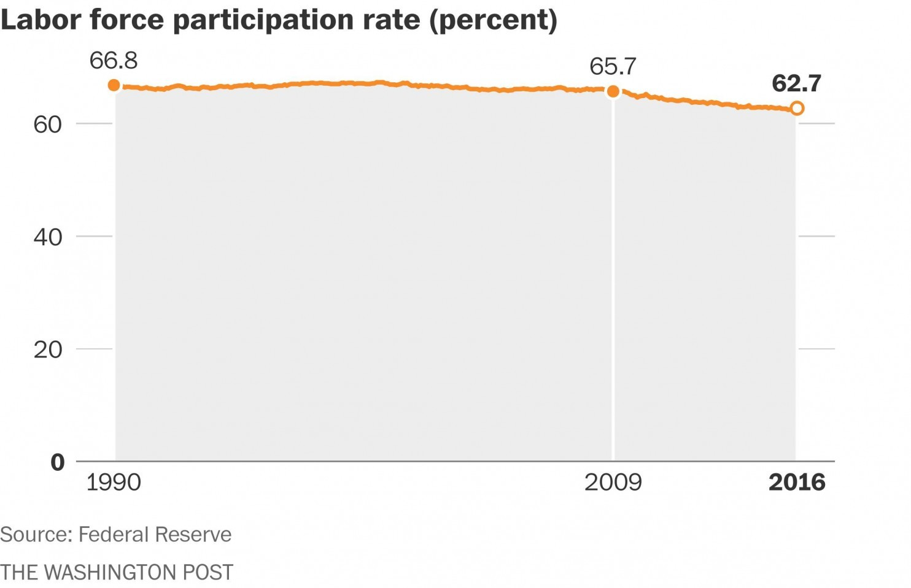

Of course, one could also show how many new jobs were added, or the state of the unemployment rate. But given that this is, at last, accurate and comprehensible, we'll let it slide.

Black inequality

This is an interesting one. The creator of these graphs uses calculations of what's known as the "Gini coefficient" for black Americans, data that is again available from the Federal Reserve. What we're talking about here isn't inequality in the sense of racial justice; it's income inequality.

The Gini coefficient estimates how far from a perfectly equitable distribution of income a group happens to be. The formulas for this are complex, so it's nice that the Fed has already taken care of it.
Here are the coefficients for both whites and blacks since 2002, when the Fed data begins.

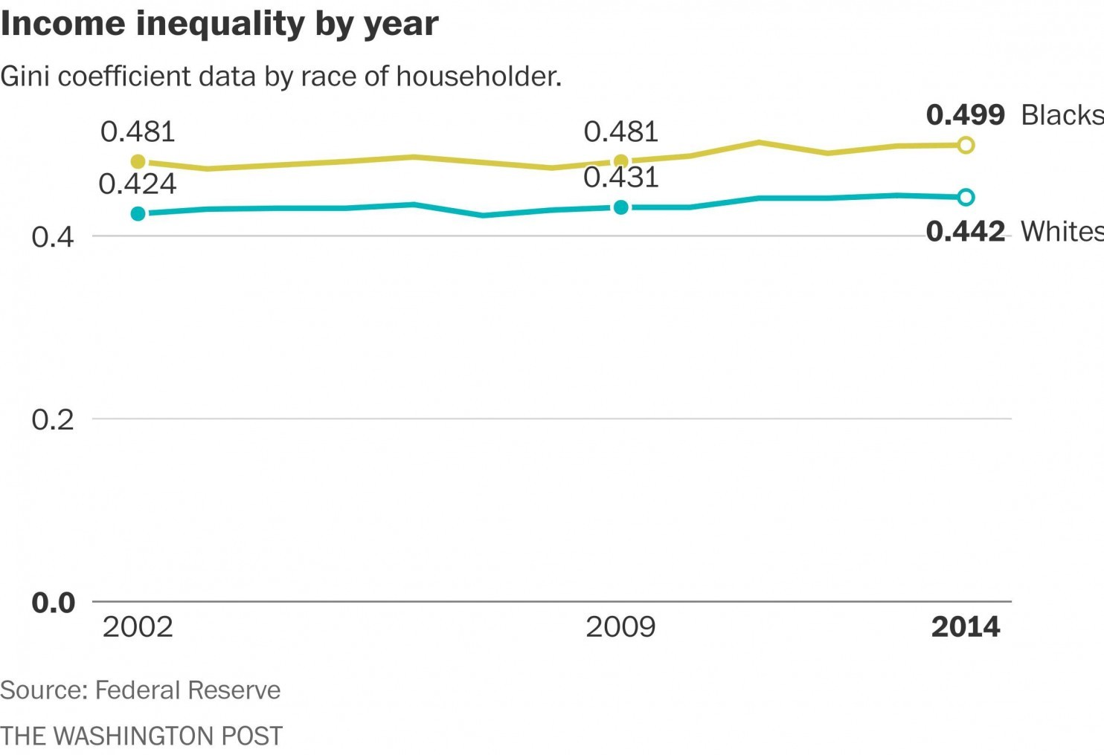

Notice that the variation is much more subtle in this chart. That's because the vertical axis shows a wider range. Yes, income inequality increased, but not that dramatically.

Median family income

This one is refreshingly straightforward. Here's what the Fed has to say.

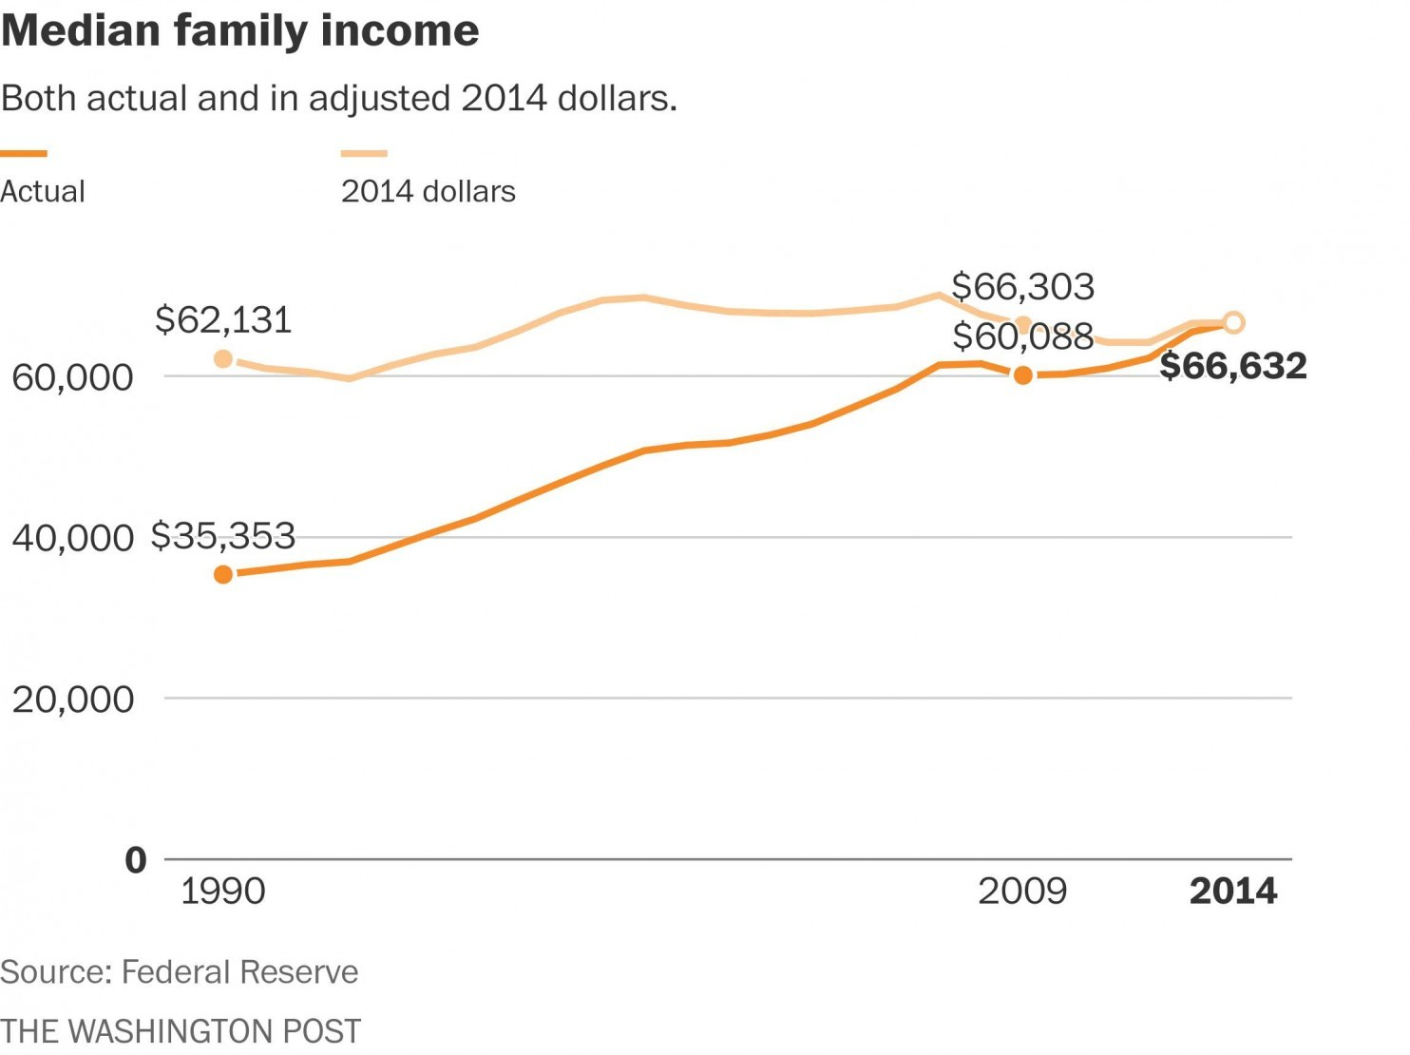

This doesn't match the Trump chart, mind you, and it's not clear why. Oh well. Here's the Fed's data, if you want to look for yourself.

Home ownership

Another straightforward one! This is the percentage of houses that are owner-occupied.

Again, the rate has declined under Obama -- a decline that began under Bush.

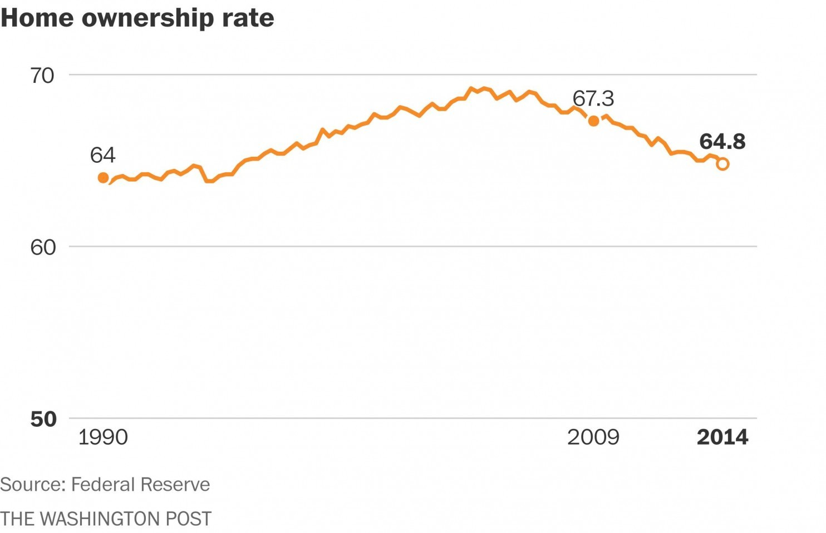

Why? In part because it was home ownership problems that precipitated the recession. Bad home loans and the rapid expansion of home ownership played key roles in creating the conditions that led to the economic collapse. As a result, home ownership rates dropped.

But this graph, at least, is fairly accurate, if a bit deceptive in where it places the blame. That's not true for many of the others.

So why did Trump tweet it? Because, as has often been the case, the details are less important than the political point. If a bunch of graphs claim to show how Obama has been bad for the economy, boom. Retweet. If some jerk goes through each one and notes why it's wrong or skewed, that doesn't detract from the main point, which is that Obama is bad. If challenged, Trump can simply blame the originator of what he retweeted, which he has often proven willing to do.

And that, in a nutshell, is why fact-checking things like this is so often thankless.
* * *
We just want to add one small comment on the author's conclusion (we skimmed that part). It's "thankless", Philip, because you just spent hours "checking" what are charts of facts, data that can be pulled up in seconds by anyone who has a bloomberg, and in minutes by everyone else.
What you ignored to say is that what you did is not actual "fact-checking" - because numbers are always and only numbers - but an attempt to manipulate your audience into deriving a specific set of conclusions precleared by the WaPo editorial board. This is why when we first created the chart, we let it speak for itself without any clarification - as none is needed - instead of having to "explain" it in a 1,000 word essay. Unlike you, we think our readers are smart enough to draw their own conclusions when presented with the facts. On the other hand, the fact that you provide "value" by wasting your time in a desperate attempt to brainwash your readers into believing your "fact-checked" conclusion probably explains why the once mighty Washington Post, which many, many years ago a truly powerful media outlet, and made presidents tremble and/or resign, was recently acquired for a fraction of the value of a tabloid like Buzzfeed.

